Land Auction
Werdna "Sally" Hubbard L.E& Hubbard Family Trust
156+/- Acres, Guthrie County, Iowa
- Saturday
- February 6th 2021
- 10:00 AM
Casey Community Building 104 West Sherman St. Casey Iowa
Open house by appointment: Call 641-740-0102 to preview the home and building site.
Auctioneer Comments: Gene & Sally Hubbard's family owned this land since 1910. Sally and Gene raised 6 children on this land. Due to her recent death the family has made the decision to sell this fine Guthrie County land.
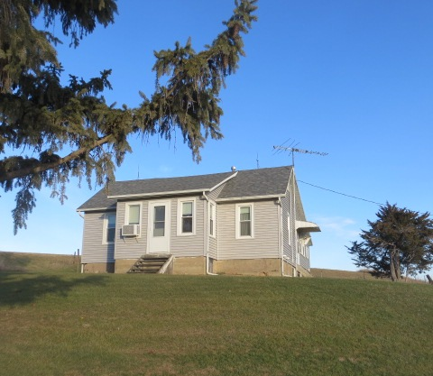
Highlights
This farm acre amounts are based on FSA maps and Beacon, Guthrie County Assessor's measurements and contains 156 acres.
- NW 1/4 Sec. 29 Thompson Twp. Guthrie C. Iowa
- 156 +/- Acres 140.66 cropland acres
- 53.2 Corn Suitability Rating
- FSA Yields Corn 146-Beans 42
- Improvements 3 BR 1 BA 905 s.f. Home 1 car attached garage with full basement
Property Location: From Casey Iowa, West 2 miles to Juniper Ave, North 3/4 mile. Land is on east side of Juniper. Address 3326 Juniper Ave., Casey Iowa. Legal Descriptions: NW 1/4 Section 29 Township 78-N Range- 32 West of 5th P.M. Guthrie County, Iowa.

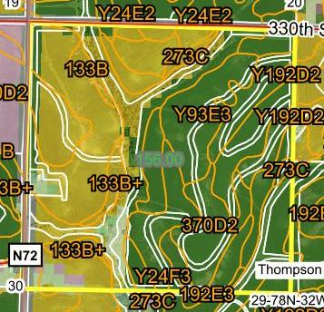
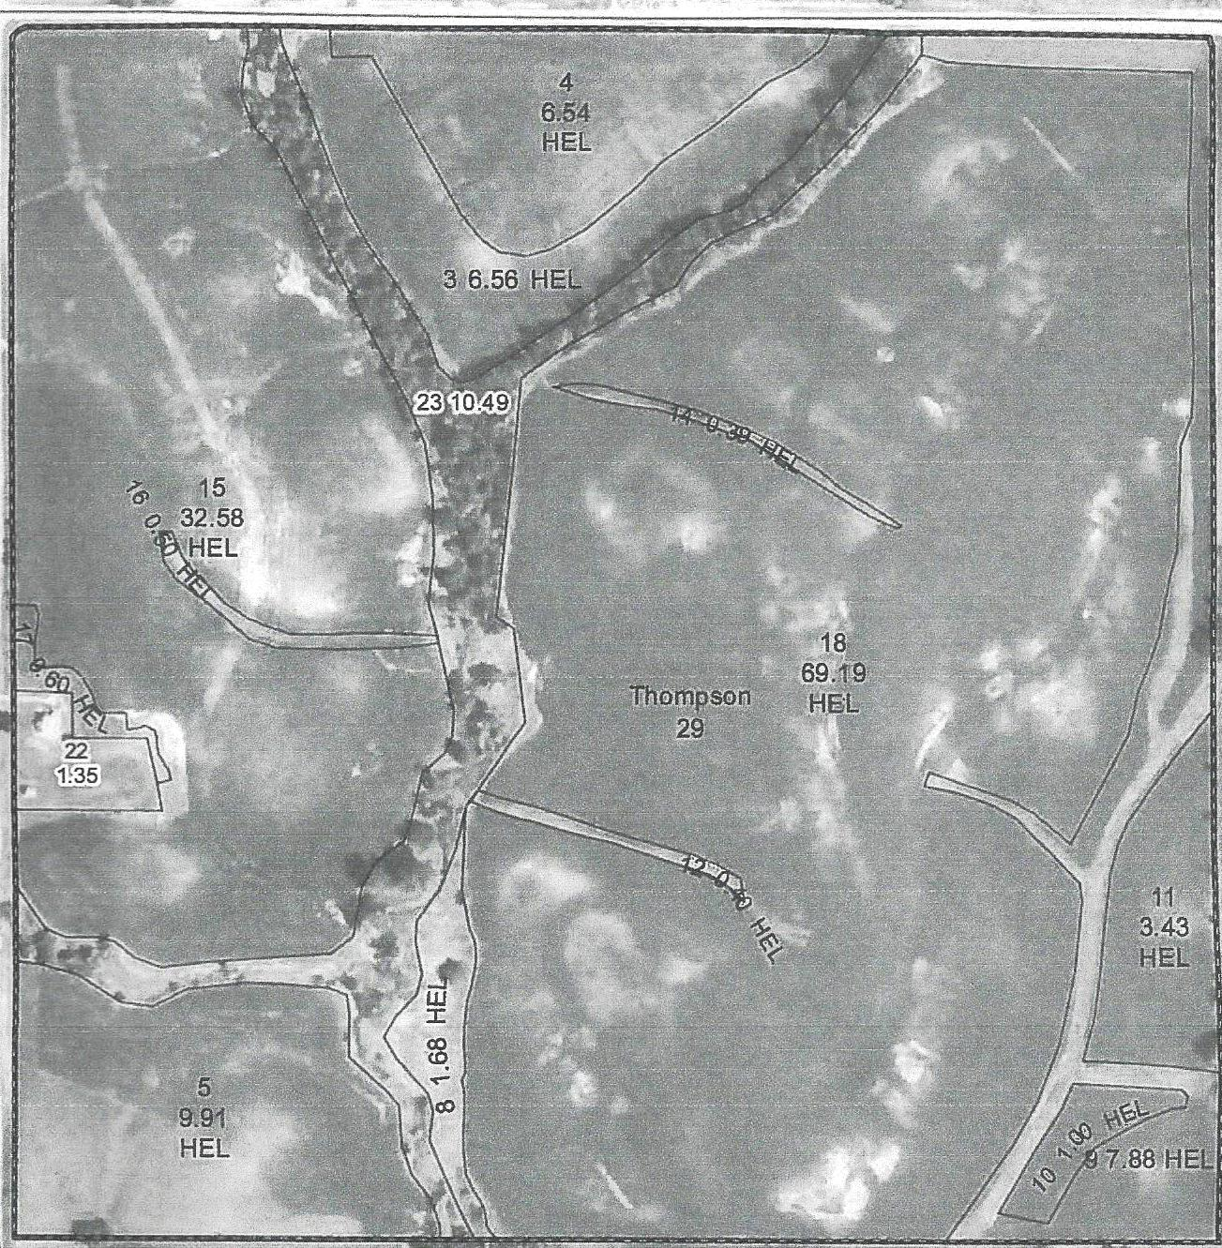

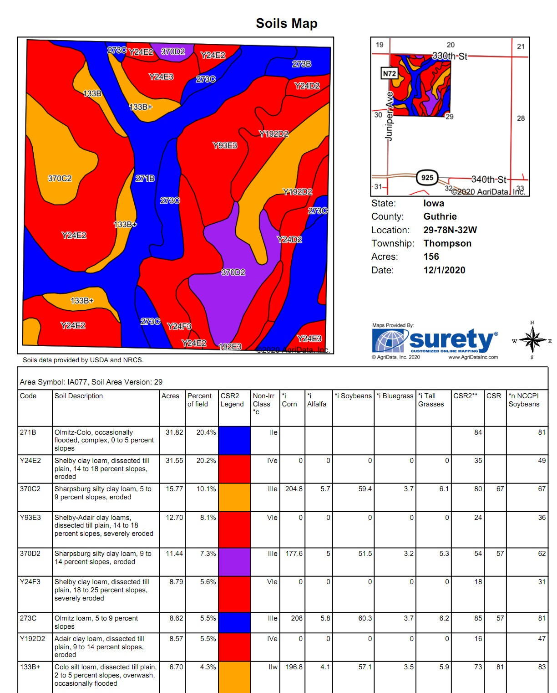
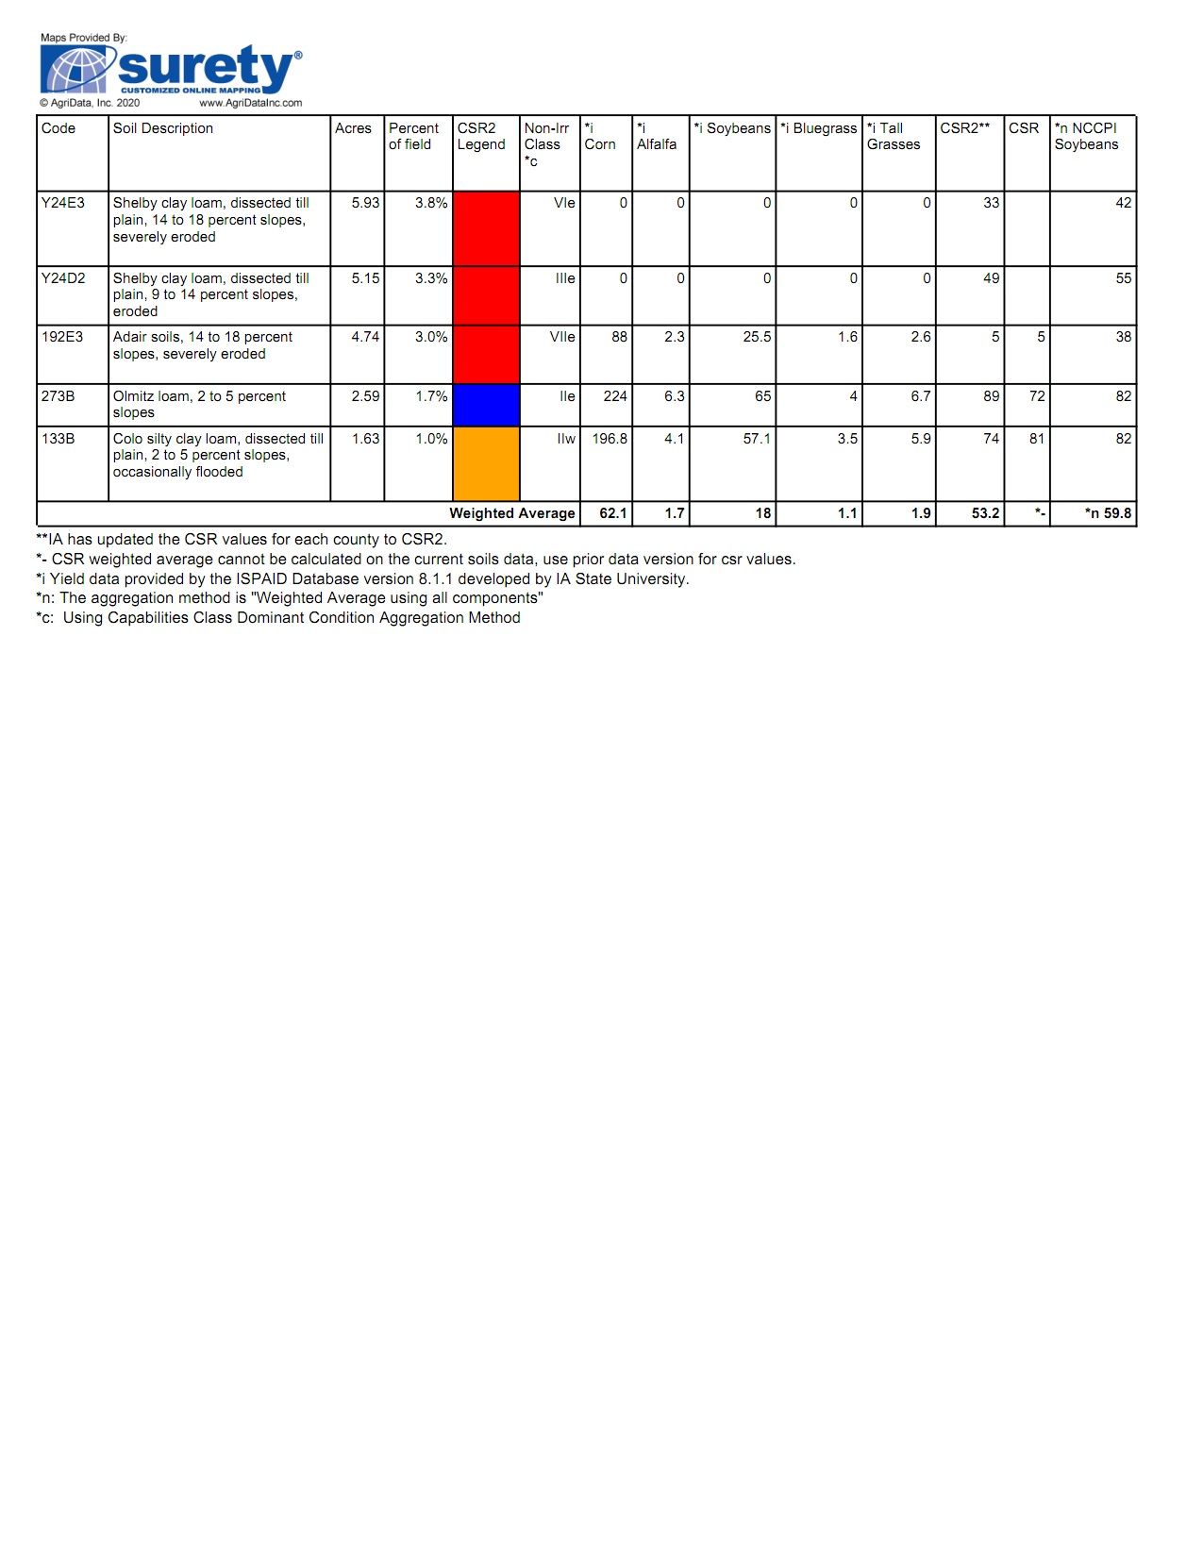

Auction Terms
Sale Method: The real estate will be offered in 1 tract. All bids are open for advancement until the auctioneer announces that the real estate is sold and the bidding for that tract is closed. Prior approval is required on all Absentee bids or phone bids. Final sale is subject to seller's approval or rejection.
Agency: Wedemeyer Auction & Realty and its agents are acting as agents for the sellers.
Announcements: Information provided is deemed reliable from all sources. Wedemeyer Auction and Realty & the sellers make no guarantees or warranties as to the accuracy of all stated facts. All potential buyers are urged to make your own inspections and to conduct your own investigations and follow your own conclusions. All sketches dimensions and measurements are listed as more or less. Any announcements auction day take precedence over printed materials or oral statements. Wedemeyer Auction and Realty reserve the right to reject any bids from persons or persons deemed unqualified to fulfill a real estate contract.
Closing: will be on or before March 1, 2021 or on a date in agreement to all parties. The balance of the purchase price will be payable at closing in cash (guaranteed funds, or by wire transfer at the discretion of the Auction Company and the sellers attorney, Mark Otto of Otto Law Office, Newton, Iowa
Possession: will be on or before March 1, 2021- landlord/tenant lease has been terminate prior to sale date.
Taxes: Taxes will be prorated to the date of closing $2,954 Annual amount.
Minerals: All mineral rights will be conveyed by the Seller.
Conditions: Sale is subject to all easements of record, and leases. Each bidder is responsible for inspections and inquiries and due diligence concerning the property. The property is sold-AS-IS. See Code of Iowa SF261 regarding time of transfer for Private sewage systems in regards to transfer by trusts.
Earnest Payments: 10% down day of sale with balance upon closing on or March 1, 2021
Contract & Title: Immediately upon conclusion of auction the successful bidder will enter into a real estate contract and provide the required earnest deposit. The seller will provide buyers with a current abstract of title at their expense. Sale is not contingent upon Buyers Financing. Buyers will have all financing arrangements pre-arranged and in place the day of sale.
Survey: The parcel will use the existing survey and no new survey will be ordered by sellers.


Wedemeyer Auction & Realty and our agents and staff understand the importance of staying safe thru this Covid-19 outbreak. With this in mind we want to remind auction attendees as well as our staff to practice social distancing & proper hygiene while in larger group settings as outlined by local, state and federal agencies. Community Building entrance will require masks. If you do not have a mask one we will provide one but attendees are urged to bring their own. We want our clients and attendees to stay safe. If you are not feeling well stay home. We will see you at the next auction.


